Love Is A Battlefield

PROGRAM & MARKETING COPY
Program Credits, Copy, and Reviews

CONCRETE DROPS THEATRE (Brooklyn, NY)
www.ConcreteDrops.com

CREDITS

Concrete Drops Theatre
Presents
Love Is A Battlefield

Written by Martin Dockery

Dramaturgy by Vanessa Quesnelle

Starring Vanessa Quesnelle & Martin Dockery

SHOW DESCRIPTION

Battle lines are drawn with deceit and desire as a man and woman spar over a future that may be just out of reach - unless someone’s willing to do the unthinkable.

PULL QUOTES

“A gripping drama… wonderfully complex and layered.
–New Ottawa Critics

“A highly enjoyable, high-stakes tale of amour and war.”
–Orlando Sentinel

“Cunning, playful, flirtatious, mysterious, and barbed.”
–Edmonton Journal

“Credulity meets manipulation in this gripping, twist-and-turn two-hander…. A welcome addition to Dockery’s canon.”
–Ottawa Citizen

“If you like your drama classically fun, then this is a great play to catch.”
–Plank Magazine

“The ultimate revelation is as surprising as the results of the [characters’] skilled manipulation… Dockery and Quesnelle are absolutely terrific together.”
–Vancouver Presents

“Chemistry that crackles.”
–Winnipeg Free Press

“There are a number of great things to say about this performance: Quesnelle and Dockery are phenomenal actors and their cheeky banter will have you laughing thoughout. Their skills as dramaturg and playwright nail down a certain story in a near perfect retelling.”
–On Stage Ottawa

“A riveting performance that ought not to be missed.”
–New Ottawa Critics

“The tension builds and releases in dramatic fashion – it’s compelling.”
–Vue Weekly

“Riveting.” –Apt 613

“The epitome of the best in fringe performance… A high class performance by the royalty of summer fringe.”
–Capital Critics Circle

Full reviews and links to the articles are below

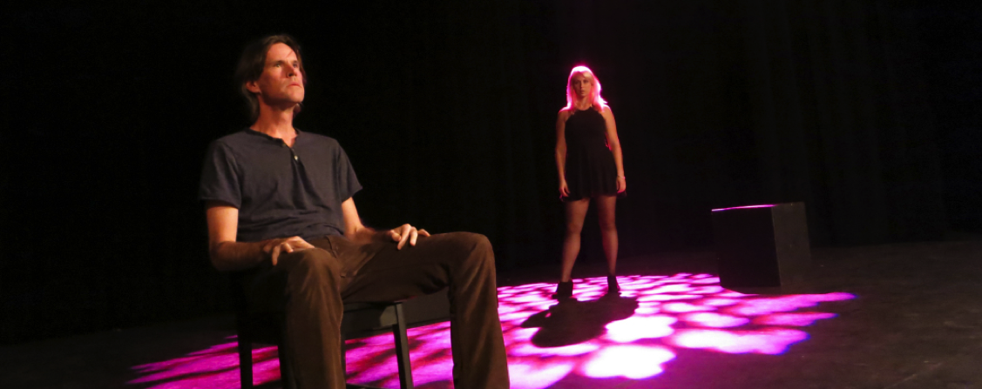
Concrete Drops Creates Gripping Drama with New Work June 18, 2016 / Brie McFarlane
The eagerly anticipated new work from dynamic duo Martin Dockery and Vanessa Quesnelle (better known here as Concrete Drops), Love is a Battlefield, makes its Canadian premiere at the Ottawa Fringe Festival this year and suffice to say it’s well on its way to being another great piece for this company. Dockery and Quesnelle appear to be experts in creating tension on stage through the constant power struggles between their characters and the gripping drama they create is constructed through their carefully measured dialogue alone. Love is a Battlefield is an exciting journey filled with suspense, Pat Benatar, and fine whisky.
The story is wonderfully complex and layered, as is characteristic of this company. A beautiful female singer and a ‘lowly’ DJ meet up to record a song and as the situation begins to unravel they discover that the pretenses they originally met under are as false as the very narratives they had just been spinning for each other. All is not what it seems in this world with the story following many twists and turns, leaving the audience left to wonder what’s going to happen next? and simultaneously what’s already happened here? You’re never really quite sure who has the power between the two characters as they fence back and forth constantly with their barbs and quips- pushing away and pulling back in. It’s not until the very end reveal do you realize that neither had any power to begin with.
The performances are, in themselves, very enjoyable to watch as Dockery and Quesnelle (who are, yes, married in real life) have this great natural chemistry on stage and respond so genuinely to one another. Love is a Battlefield undeniably has tiny elements of Moonlight After Midnight scattered throughout it (i.e. the way they begin on stage even), however the text in this instance is slightly more traditional in its dramatic narrative. I appreciate the nod to the Chekovian gun and the clear conflict-climax-resolution style plot line is a bit of a departure (a nice departure to be sure) from what I’ve seen from this company previously.
I would recommend this piece to anyone who hasn’t seen any of Concrete Drops’ work before, because it’s sure to get you hooked and fans of Quesnelle and Dockery will rejoice their favourite creative couple back on stage once more. As per usual, my yearly PSA, get your tickets early as this company tend to put butts in seats fast.
https://newottawacritics.com/2016/06/18/concrete-drops-creates-gripping-drama-with-new-work/<INPUT NAME=\



Love Is A Battlefield

Published on: August 9, 2016
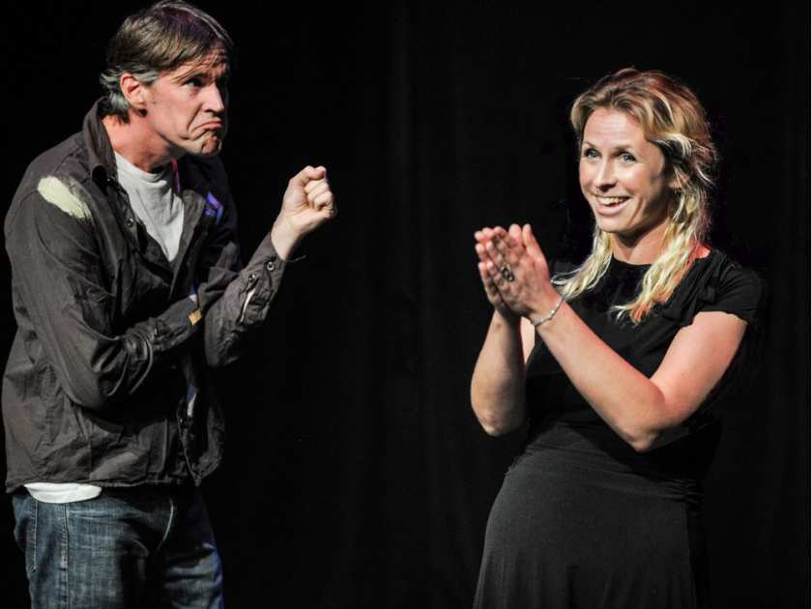
In this cunning little two-hander, an out-of-work producer has been enlisted to record a demo CD for a rich trophy wife with a decent voice and time on her hands.
The cat-and-mouse dynamic between Dockery and Vanessa Quesnelle, real-life husband and wife, is playful, flirtatious, and for reasons that are mysterious at the onset, barbed. She pesters him to have a bourbon; he resists. There’s a certain acid to her amusement. “Being sober is no excuse for lack of skill.” She wins.
Their banter constantly loops back to her husband, currently reposing beside the mansion pool, out of our sight and in theirs. And she needles him constantly about his ex-girlfriend. You wonder who is manipulating whom. What seems to be a romantic comedy — you know, antipathy that never quite conceals attraction — might possibly have something else going on. A soupçon of Ira Levin perhaps?
Or not. My lips are sealed: There’s almost nothing I should tell you about escalating plot complications, inserted slyly by the playwright. But I can tell you that the performances are expert at casually cross-hatching the dialogue, and judging the weight of the piece.
Liz Nicholls, as seen at the Winnipeg Fringe
http://edmontonjournal.com/entertainment/theatre/fringe-review-love-is-a-battlefield



Love is a Battlefield
By Patrick Langston. Published on: June 17, 2016
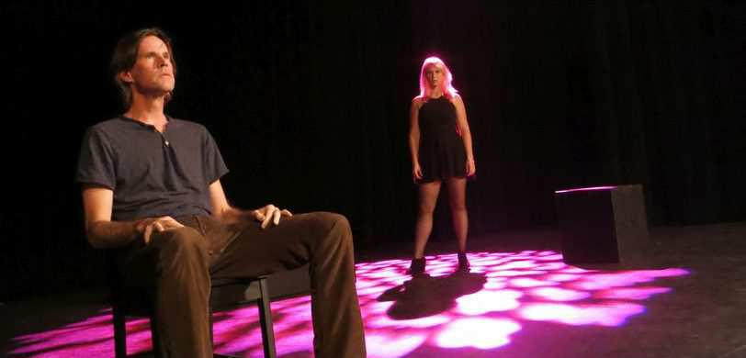
Credulity meets manipulation in this gripping, twist-and-turn of a two-hander by fringe favourite Martin Dockery. He plays a lost, naïve soul attempting to record a demo CD by a beautiful, rich songstress played by Vanessa Quesnelle. They squabble, drink, draw closer together, move apart as it slowly becomes clear that there’s more of a backstory here than first appeared. To say much more would be to say too much, but the backstory soon becomes front and centre as events grow darker and the characters – finely drawn and compellingly embodied by both actors – slowly open up before us. That Dockery and Quesnelle are married in real life adds another dimension to the drama and heightens its intimate, almost voyeuristic air. This production marks the Canadian premiere of Love is a Battlefield.
http://ottawacitizen.com/entertainment/local-reviews/fringe-festival-reviews-independent-thinking-abandoned-child-refugees-and-a-gripping-intimate-love-story



By Mark Robins on September 11, 2016
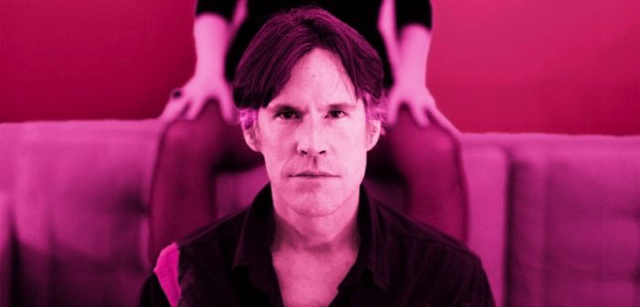
Yes, Pat Benatar’s Love is a Battlefield does make an appearance in this latest from Martin Dockery and Vanessa Quesnelle of Concrete Drops.
Like Benatar’s song which exposes that delicate balance between love and hate that exists in most relationships, this two-hander goes one step further. Through its quick 60 minutes we are fed tiny pieces about the relationship between the two. Secrets are revealed as more alcohol is consumed, but it is purely one-sided. The ultimate revelation is as surprising as the results of the skilled manipulation. To give away too much will spoil those surprises.
Dockery and Quesnelle were absolutely terrific together in 2014’s Moonlight After Midnight, here they manage the same unique chemistry.
http://vancouverpresents.com/2016-fringe/review-love-battlefield/

On Stage Ottawa

Fringe 2016: Love is a Battlefield is an old story told well
June 18, 2016 by Joseph Hutt
Love is a Battlefield, created and performed by Vanessa Quesnelle and Martin Dockery, is a familiar story about love and longing. When the wife of a rich man (Quesnelle) wants to start singing, he calls in a debt and brings in a “down-on-his-luck producer” (Dockery) to help her record a track. As the drinks start to flow and the verbal sparring begins, it soon becomes clear that business is one of the last things on their mind.
There are a number of great things to say about this performance. Quesnelle and Dockery are phenomenal actors, and their cheeky banter oozes with an overly familiar rapport and will certainly have you laughing throughout the show.
Without ever needing them to explain how their minds work, Dockery and Quesnelle are able to broadcast their characters’ feelings and motivation through the subtlest implications.
Some of this stems from the finely honed acting skills of both Dockery and Quesnelle, but also from their skills as playwright (Dockery) and dramaturg (Quesnelle), creating a script that allows them to say so much without making them say too much. This is Dockery and Quesnelle’s attempt at nailing down a certain story in a near perfect retelling. It’s a pretty cool motivation to be working from.

http://www.onstageottawa.com/loveisabattlefieldreview/

Don’t Miss “Love is a Battlefield”!
June 24, 2016 / Wes Babcock
Perennial Fringe favourites Martin Dockery and Vanessa Quesnelle bring a brand new high stakes drama to life with a pair of vibrant performances in Love is a Battlefield.
Dockery and Quesnelle are a pleasure to watch as they slowly unearth the depths of their characters’ insecurities through the layers of armor that humans frequently erect between one another. As usual in a play by Dockery, I can’t say too much about the plot or its development without ruining the experience of watching it unfold on stage.
The physical interaction between the characters develops as their emotional truths are uncovered with each aggressive thrust of the dialogue. These are two characters that will fight to defend their secrets as a sort of talisman against hurt from the outside world, and neither opens up willingly or without reservation. The show explores this tension in a nuanced manner, and that is an admirable accomplishment.
This show is in progress, and carries with it a vast wealth of potential in the strong creator/performers at its helm. I look forward to witnessing a later stage of the development it will undergo on the Fringe tour, and so should you. These two deliver a riveting performance that ought not to be missed.
https://newottawacritics.com/2016/06/24/dont-miss-love-is-a-battlefield/

Capital Critics Circle

Love is a Battlefield – A High class performance by Fringe Royalty

Reviewed by Alvina Ruprecht - 17 June, 2016
The epitome of the best in Fringe performance, actor, director, story teller, mimic, mime, creator of stage events that are completely original, Martin Dockery is back in Ottawa under the fringe spotlight with his just as brilliant partner Vanessa Quesnelle. The woman with the velvet singing voice that one could listen to all day, as the character says in this show, also proves how she can hold her own in this brief encounter that appears to be improvised but that is tightly scripted I was told.
A singer has hired the character played by Dockery to make a recording of her latest song. It all takes place in her apartment while her husband it out. Simple enough; however as emotions heat up, unexpected information is discovered, the simple arrangement becomes an accumulation of complex possibilities and relationships that make the dialogue more and more ambiguous as the interlocutors, avoid clear answers, respond to questions with questions, and create an atmosphere of mistrust that persists until the very end, which in itself is purposely unclear.
The dialogue gets its hooks into us rapidly because it is so relaxed and untheatrical. It made the performances flow like cool water as the two of them play off against each other, creating a great sense of sexual tension that never quite has the chance to declare itself. Obviously on purpose.
A high class performance by the royalty of summer fringe. Go see this.
http://capitalcriticscircle.com/ottawa-fringe-2016-love-is-a-battlefield/

